Department of Computer Science and Engineering
The University of Texas at Arlington

Team: Survivors
Project: Sight By Touch
Team Members:
Gerardo Guevara
Kevin Tran
Victor Rodriguez
Margaret Floeter
Henry Loh

Last Updated: 12/7/2013

Table of Contents
Table of Contents 2
Document Revision History 5
List of Figures 6
List of Tables 7
1. Introduction 8
1.1 Purpose and Use 8
1.2 Product Concept 8
1.3 Product Scope 9
1.4 Key Requirements 10
2. Meta Architecture 12
2.1 Architectural Vision 12
2.2 Guiding Principles 12
2.2.1 Adaptability 12
2.2.2 Maintainability 12
2.2.3 Modularity 12
2.2.4 Portability 12
2.2.5 Real-time Performance 13
2.2.6 Reliability 13
2.2.7 Usability 13
2.3 Assumptions 13
3. Layer Definitions 14
3.1 Data Driver Layer 15
3.2 Warning Layer 15
3.3 Notification Layer 15
4. Layer Description 16
4.1 Data Driver Layer 16
4.1.1 Overview 16
4.1.2 Assumptions 16
4.1.3 Responsibilities 16
4.1.4 Dependencies 16
4.1.5 Subsystems 17
4.2 Warning Layer 20
4.2.1 Overview 21
4.2.2 Assumptions 21
4.2.3 Responsibilities 21
4.2.4 Dependencies 21
4.2.5 Subsystems 21
4.3 Notification Layer 24
4.3.1 Overview 24
4.3.2 Assumptions 24
4.3.3 Responsibilities 24
4.3.4 Dependencies 24
4.3.5 Subsystems 25
5. Inter-Subsystem Data Flow 29
5.1 Inter-Subsystem Data Flow Section 29
6. Requirements Mapping 31
7. Operating System Dependencies 33
7.1 Data Driver Layer 33
7.2 Warning Layer 33
7.3 Notification Layer 33
8. Testing Considerations 34
8.1 Overall Considerations 34
8.1.1 Durability 34
8.1.2 User 34
8.2 Layer-level Considerations 34
8.2.1 Data Driver Layer 34
8.2.2 Warning Layer 35
8.2.3 Notification Layer 35

Document Revision History
Revision Number | Revision Date | Description | Rationale
1.0 | 11/30/2013 | First ADS Draft | Team’s Initial Draft

List of Figures
Figure # Title Page #
3-1 Architecture Layers Diagram #
4-1 Data Driver Layer #
4-2 User Input Driver #
4-3 Distance Sensor Driver #
4-4 Battery Level Driver #
4-5 Warning Layer #
4-6 Detection Filter #
4-7 Warning Manager #
4-8 Notification Layer #
4-9 On/Off Notification #
4-10 Object Notification #
4-11 Low Battery Notification #
5-1 Architectural Data flow Diagram #

List of Tables
Figure # Title Page #
1-1 Key Architectural Design Requirements #
4-1 User Input Driver Inter-layer Interfaces #
4-2 User Input Driver Public Interfaces #
4-3 Distance Sensor Driver Inter-layer Interfaces #
4-4 Distance Sensor Driver Public Interfaces #
4-5 Battery Level Driver Inter-layer Interfaces #
4-6 Battery Level Driver Public Interfaces #
4-7 Detection Filter Inter-layer Interfaces #
4-8 Warning Manager Inter-layer Interfaces #
4-9 On/Off Notification Inter-layer Interfaces #
4-10 On/Off Notification Public Interfaces #
4-11 Object Notification Inter-layer Interfaces #
4-12 Object Notification Public Interfaces #
4-13 Battery Notification Inter-layer Interfaces #
4-14 Battery Notification Public Interfaces #
5-1 Inter-Subsystem Data Element Descriptions #
5-2 Producer-Consumer Relationships #
6-1 Requirements Mapping Table #

1. Introduction

Purpose and Use
The purpose of the Sight By Touch System is to aid visually impaired individuals since they are unable to rely on their sight. More often than not, visually impaired individuals require some form of aid to help guide them, usually through the use of a cane or a service animal. Our team wishes to remove, or decrease, this dependency by allowing the user to be guided by vibrations from the system. In this way, the user’s hands will be free from having to hold a cane or a leash. With this system, a user shall be able to avoid collision with any obstacles that are found in their environment. Our team has decided to make the system an indoor and outdoor system. The system shall lead the user in a safe direction by warning them when an object is within the detection range of the sensors. The system does this through vibrations from its vibration motors. When the sensors sense an object, the vibration motor closest to that object will vibrate. This system is used solely for the purpose of helping visually impaired users navigate in unknown environments. This product is not intended to be used in a crowded area because there would be too much interference from the surrounding objects.

Product Concept
The Sight By Touch system shall consist of an external belt that holds the main battery, which connects to the sensors and vibration motors. When the user is not using the product and wishes to charge the batteries, the batteries will be removed from the system and put into a docking station to charge.
The system will be a full-blown suit with the sensors underneath the clothes and with their wires connected to the microcontroller. The sensors will be detachable to allow for flexibility and cleanliness. The system will focus on the front of the user (180 degrees, at least a 3 feet radius horizontally, and from the neck to the ankles vertically).
There will be multiple vibration motors distributed along the system, embedded in the suit. When the sensor connected to those vibration motors senses an object within the range, the sensor will send a signal to the microcontroller, which will then forward the message to the vibration motor. There can be multiple vibration motors vibrating at the same time and at different intensities depending on where the object is located. The closer the object is the more intense the vibration will be. In addition, depending on the location of the object being detected, the vibration motors closest to that object will vibrate the most.
The belt will allow the user to interface with the device. The interface will have an on/off button to turn the sensors on/off. In addition, there will be a knob that allows the user to adjust the range that the sensors will detect. There will be no external elements for all the functions and data manipulation will be done internally.

Product Scope
The Sight By Touch system is made to aid visually impaired users through the use of vibrations. Users of the Sight By Touch system will be able to move around and gauge where they are. When a user walks near an object, the system will vibrate in the direction where the object is closest. This warns the user that there is an object nearby and thus prevents the user from colliding with the object. With the use of these vibrations created by the system, a visually impaired user will be able to avoid obstacles. The system will not be able to detect the absence of flooring such as a hole or a staircase.
The intended audiences for the Sight By Touch system are individuals who are visually impaired. We consider the visually impaired to be based on the following metrics provided by the American Optometric Association:
- 20/70 to 20/160 is considered moderate visual impairment, or moderate low vision
- 20/200 to 20/400 is considered severe visual impairment, or severe low vision
- 20/500 to 20/1,000 is considered profound visual impairment, or profound low vision
- less than 20/1,000 is considered near-total visual impairment, or near total blindness
- no light perception is considered total visual impairment, or total blindness

Key Requirements
The follow table, 1-1, contains the key requirements for the Sight by Touch System. These requirements are the main requirements that will determine the architectural design of the system. The full list of requirements can be found in the System Requirements Specification document.
Number | Requirement | Description
3.1 | On and Off | The system shall be able to be turned on/off by the click of a button followed by some notification that the system was powered on or off. The preferred method of notification is through vibrations.
3.2 | Detect Obstructions | The system shall be able to detect the presence of nearby objects that are in front and/or to the sides of the user that can impede the user from moving forward. The detection area of the system will need to cover at least a 3-foot radius in front of the user including the sides and vertically from the neck to the ankles.
3.3 | Obstruction Notification | The system shall be able to warn the user of the presence of nearby objects through the use of vibrations. The intensity of the vibrations felt by the user will correspond to the direction and the distance of the object(s) that the system has detected.
3.4 | Battery Powered | A rechargeable battery shall power the system.
3.5 | Inconspicuous Appearance | The system shall be as discrete as possible in order to attract the least amount of attention.
3.6 | Low Battery Notification | The system shall be able to notify the user when the battery has less than an hour left of charge and again when the battery has less than thirty minutes left of charge.
3.7 | User Friendly | The system shall be user friendly so that anyone with or without sight can operate it. The functions will be intuitive and easy to learn.
5.2 | Real-Time Response | The system shall be able to detect objects and notify the user through vibrations between 30 milliseconds to 100 milliseconds.
5.3 | Detection Quality | The system shall be able to detect objects within 10 feet max.
5.4 | Vibration Intensity | The system shall have a safe vibration intensity of 0.063 m/s2 to 1.15 m/s2. This range ensures that the system can warn the user without harming the user.
5.5 | Battery Life | The rechargeable battery shall last between 6-10 hours on full recharge cycles.
6.4 | Heat Dissipation | The system shall dissipate heat produced by the components of the system to prevent overheating.
6.6 | Skin Irritation | The system shall not irritate the skin of the user. Vibrations should be kept at a safe range to avoid harming the skin of the user.
8.1 | Weight | The entire system shall be weight under six pounds.
8.3 | Adjustable Range | The system shall be able to allow the user to select from the predefined max range radius of 3 or 10 feet.
Table 1-1: Key Architectural Design Requirements

2. Meta Architecture
The Meta Architecture section describes the Architectural Vision, Guiding Principles, and Assumptions that will affect how we will design the Sight by Touch System. The Architectural Vision is an overview of the system layers and gives a brief explanation of the overall functionality of the system. Our team came up with Guiding Principles to help guide us when making architecture design decisions. We list each principle and the reason as to why the team feels it is important. Key assumptions that the architectural design is based on are also listed in this section. Finally, we list tradeoffs that were made during the initial design of the architecture.

2.1 Architectural Vision
In order to have the most efficient data flow, our architectural structure has been broken up into three layers. These layers include the Data Driver layer, the Warning layer, and the Notification layer.

2.2 Guiding Principles

2.2.1 Adaptability
The user will be able to adapt to the Sight By Touch system’s user interface and the vibrations’ position and intensity to navigate in real world environments. This will affect the number of distinct vibration patterns the system will use along with the flow of the data.

2.2.2 Maintainability
The Sight By Touch system shall be designed and built in a way such that the finished product will have replaceable components. The purpose of this guideline is to allow for the replacement of components that are defective so that the distributor does not have to replace the entire system. This will affect what type of data and the way that data is passed between subsystems.

2.2.3 Modularity
The Sight By Touch system shall be designed so that the software interface and the hardware components are self-contained units and not specifically dependent on each other. Any changes to the software interface and/or hardware components will not affect the other unit.

2.2.4 Portability
The Sight By Touch system shall assist the user to navigate wherever they need to go. So, the system must be compact, lightweight, and especially portable so that the user may be able wear and utilize it. This will limit the number of layers that we have.

2.2.5 Real-time Performance
The Sight By Touch system shall be designed so that the functionality may be performed in real-time in order to provide the user with adequate time to make decisions in navigating. This will limit the number of subsystems/layers and minimize the length of the data flow.

2.2.6 Reliability
The Sight By Touch system must be accurate and functional so that the user will be able to safely navigate in real world environments. This will affect the number of subsystems/layers and the data flow.

2.2.7 Usability
The Sight By Touch system will be designed so that it can be easily worn and operated by a visually impaired individual. This will affect the complexity of the system.

2.3 Assumptions
There are a number of assumptions that have been made by the development team that will be used to design and implement the Sight by Touch System. These assumptions will guide many decisions made during the development life cycle. Here is a list of assumptions that we have made:
- The system is only meant to assist the visually impaired.
- The user has the ability to walk and the use of a least one hand.
- The system will be turned off when the user is sitting down or in a crowded place.
- The user can charge the system at least once.
- The user will use an umbrella when it is raining outside.
- The user is not going to run with the system on.
- The user will use the system in mainly dry areas.
- The system will be for indoors and outdoors use.

3. Layer Definitions
This section describes Sight by Touch System architecture, which is the overall structure of how the system will be built. The Sight by Touch System architecture consists of three main layers. The layers include the Data Driver layer, the Warning layer, and the Notification layer. The architecture design is shown in Figure 3-1.
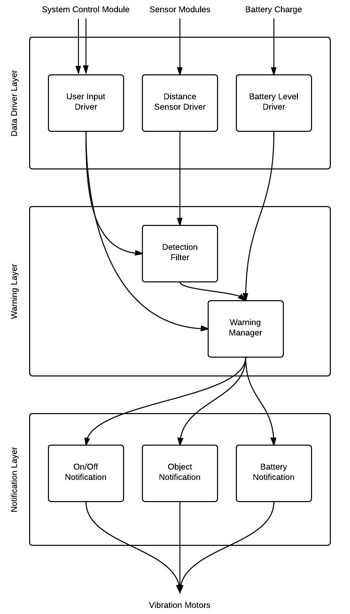
Figure 3-1: Architecture Layers Diagram

3.1 Data Driver Layer
This layer is responsible for standardizing the input from the user, sensor modules, and the battery. This layer will be abstracting multiple inputs and interpreting that data in a way so that the system and external hardware can communicate successfully.

3.2 Warning Layer
This layer is responsible for processing all the input and output signals. This layer will be making decisions based on the input received from the Data Driver Layer and triggering notification messages to the Notification Layer.

3.3 Notification Layer
This layer is responsible for sending all the signals to the vibration motors in order to notify the user of each event. The events include the On/Off Notification, the Objected Detected Notification, and the Low Battery Notification.

4. Layer Description
This section will describe each of the layers defined in section 3 in more detail such as the functions, assumptions, and subsystems that comprise each layer.

4.1 Data Driver Layer
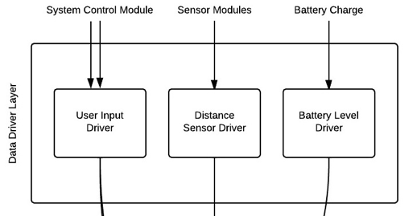
Figure 4-1: Data Driver Layer
4.1.1 Overview
The Data Driver Layer will provide an interface between the external hardware and the Warning Layer. These inputs include data from the System Control Module, Sensor Modules, and the Battery.

4.1.2 Assumptions
- The system will only receive data from the System Control Module, Sensor Modules, and the Battery.
- The data will be used in real time so no database to store the data will be necessary.
- Any external input used must be able to communicate with the interface.

4.1.3 Responsibilities
This layer is responsible for abstracting and reformatting the input from the System Control Module, Sensor Modules, and the Battery in a way that the Warning Layer can process it.

4.1.4 Dependencies
This layer will be dependent on the type of user interface, the data the distance sensors output, and battery measuring mechanism used.

4.1.5 Subsystems
4.1.5.1 User Input Driver
The User Input Driver is a subsystem of the Data Driver Layer. This subsystem will be responsible for handling the input received from the user and reformatting it so the Warning Layer can process it.
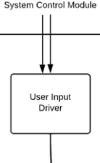
Figure 4-2: User Input Driver
4.1.5.1.1 Assumptions
- The user will be able to power the system On/Off.
- The user will be able to change the detection range.
- Other options will not exist.
4.1.5.1.2 Responsibilities
This subsystem will be responsible for providing an interface between the System Control Module and the System.
4.1.5.1.3 Dependencies
This subsystem will be dependent on the type of user interface used.
4.1.5.1.4 Subsystem Inter-layer Interfaces
Method | Description | Information  Required | Information Returned
sendNewState | The User Input Driver will interpret and send the State of System to the Warning Layer. | State of System | None
sendUpdatedRange | The User Input Driver will interpret and send the detection range to the Warning Layer. | Detection Range | None
Table 4-1: User Input Driver Inter-layer Interfaces
4.1.5.1.5 Subsystem Public Interfaces
Method | Description | Information  Required | Information Returned
userInputListener | The User Input Driver will listen for messages from the System Control Module. | User Input Data and Event Type | None
Table 4-2: User Input Driver Public Interfaces
4.1.5.2 Distance Sensor Driver
The Distance Sensor Driver is a subsystem of the Data Driver Layer. This subsystem will be responsible for handling the input received from the Sensor Modules and reformatting it so the Warning Layer can process it.
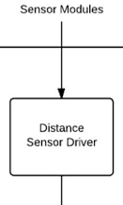
Figure 4-3: Distance Sensor Driver
4.1.5.2.1 Assumptions
  - The Sensor Modules will all work independently from each other.
  - The Sensor Modules will calculate the distance between the user and the object.
  - The Sensor Modules will do the calculations in real time.
  - The Sensor Modules will function indoors and outdoors.

4.1.5.2.2 Responsibilities
This subsystem will be responsible for providing an interface between the Sensor Modules and the System.

4.1.5.2.3 Dependencies
This subsystem will be dependent on the data the distance sensors output.
4.1.5.2.4 Subsystem Inter-layer Interfaces
Method | Description | Information  Required | Information Returned
sendSensorInfo | The Distance Sensor Driver will interpret and send the distance and sensor ID to the Warning Layer | Distance and Sensor ID | None
Table 4-3: Distance Sensor Driver Inter-layer Interfaces
4.1.5.2.5 Subsystem Public Interfaces
Method | Description | Information  Required | Information Returned
sensorInfoListener | The Distance Sensor Driver will listen for messages from the Sensor Modules. | Distance and Sensor ID | None
Table 4-4: Distance Sensor Driver Public Interfaces
4.1.5.3 Battery Level Driver
The Battery Level Driver is a subsystem of the Data Driver Layer. This subsystem will be responsible for reading the input received from the Battery and reformatting it so the Warning Layer can process it.
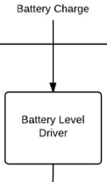
Figure 4-4: Battery Level Driver
4.1.5.3.1 Assumptions
  - The Battery Level will be checked constantly.

4.1.5.3.2 Responsibilities
This subsystem will be responsible for providing an interface between the Battery and the System.
4.1.5.3.3 Dependencies
This subsystem will be dependent on the type of battery measuring mechanism used.
4.1.5.3.4 Subsystem Inter-layer Interfaces
Method | Description | Information  Required | Information Returned
sendBatteryLevel | The Battery Level Driver will interpret and send the data to the Warning Layer. | Battery Level | None
Table 4-5: Battery Level Driver Inter-layer Interfaces
4.1.5.3.5 Subsystem Public Interfaces
Method | Description | Information  Required | Information Returned
batteryLevelListener | The Battery Level Driver will listen for messages from the Battery. | Battery Level | None
Table 4-6: Battery Level Driver Public Interfaces

4.2 Warning Layer
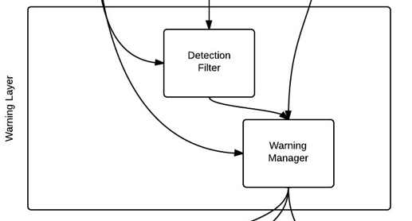
Figure 4-5: Warning Layer
4.2.1 Overview
The Warning Layer will focus on controlling the notifications that are broadcasted to the Notification Layer based on the input received from the Data Driver Layer.

4.2.2 Assumptions
- Any input must first pass through the Data Driver Layer.
- All features and functions must be performed in real-time.

4.2.3 Responsibilities
The Warning Layer will be responsible for analyzing the information received from the Data Driver Layer, determining the type of notification, and broadcasting a signal to the Notification Layer.

4.2.4 Dependencies
This layer will dependent on the type of data received from the Data Driver Layer.

4.2.5 Subsystems
4.2.5.1 Detection Filter
The Detection Filter is a subsystem of the Warning Layer that determines if the information received from the Sensor Modules is within the maximum detection range to the Warning Manager.
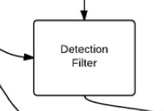
Figure 4-6: Detection Filter
4.2.5.1.1 Assumptions
  - This subsystem will not be accessible from outside of the system.
  - All features and functions must be performed in real-time.

4.2.5.1.2 Responsibilities
The Detection Filter will be responsible for determining if the distance received by a sensor module is within the maximum detection range, update the maximum range when needed, and report significant data to the Warning Manager.
4.2.5.1.3 Dependencies
This subsystem will be dependent on the data received from the User Input Driver and Distance Sensor Driver subsystems.
4.2.5.1.4 Subsystem Inter-layer Interfaces
Method | Description | Information  Required | Information Returned
detectionListener | The Detection filter will listen for messages from the User Input Driver and the Distance Sensor Driver | Maximum Detection Range, Distance, and Sensor ID | None
sendSensorInfo | The Detection Filter will relay the Distance and Sensor ID to the Warning Manager. | Distance and Sensor ID | None
Table 4-7: Detection Filter Inter-layer Interfaces
4.2.5.1.5 Subsystem Public Interfaces
This subsystem does not interact directly with the external world.
4.2.5.2 Warning Manager
The Warning Manager is a subsystem of the Warning Layer that determines the type of messages that needs to be broadcasted to the Notification Layer.
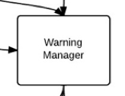
Figure 4-7: Warning Manager

4.2.5.2.1 Assumptions
    - This subsystem will not be accessible from outside of the system.
  - All features and functions must be performed in real-time.

4.2.5.2.2 Responsibilities
The Warning Manager is responsible for identifying the type of object notification, determine when the battery is low, determine the state of system and then broadcast these messages to the Notification Layer.
4.2.5.2.3 Dependencies
This subsystem will be dependent on the data received from the User Input Driver, Battery Level Driver, and Detection Filter subsystems.
4.2.5.2.4 Subsystem Inter-layer Interfaces
Method | Description | Information  Required | Information Returned
warningMessageListener | The Warning Manager will take in all types of messages coming from the User Input Driver, Detection Filter and Battery Level Driver. | Warning Message | None
broadcastMessage | The Warning Manager will send a formatted package to the Notification Layer. | Warning Message | None
Table 4-8: Warning Manager Inter-layer Interfaces
4.2.5.2.5 Subsystem Public Interfaces
This subsystem does not interact directly with the external world.

4.3 Notification Layer
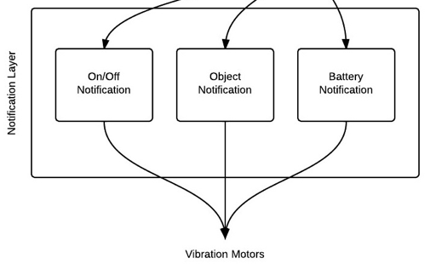
Figure 4-8: Notification Layer
4.3.1 Overview
The Notification Layer will focus on what vibration pattern the system will deliver to the User based on the type of message that was broadcasted by the Warning Layer.

4.3.2 Assumptions
- The layer will generate the high-level instructions needed to notify the user.
- The layer will be able to generate different vibration patterns.
- All features and functions must be performed in real-time.

4.3.3 Responsibilities
The Notification Layer will be responsible for making decisions on what type of vibration pattern and intensity to use to notify the user. The messages received by the Warning Layer will be processed to determine the specific vibration pattern and intensity to use to notify the user. Once a decision has been made, it will notify the user with the selected vibration pattern and intensity.

4.3.4 Dependencies
This layer will be dependent on the data received from the Warning Manager subsystem and the signals that are required by the notification devices.

4.3.5 Subsystems
4.3.5.1 On/Off Notification
The On/Off Notification Subsystem will receive messages from the Warning Manager and interpret them into appropriate instructions.
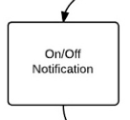
Figure 4-9: On/Off Notification
4.3.5.1.1 Assumptions
- The On/Off Notification Subsystem will have access to all of the notification devices.
- The signal will be unique.

4.3.5.1.2 Responsibilities
The On/Off Notification Subsystem will be responsible for interpreting the Warning Manager’s instructions and sending signals to the notification devices.
4.3.5.1.3 Dependencies
This subsystem will be dependent on the data received from the Warning Manager subsystem and the signals required by the notification devices.
4.3.5.1.4 Subsystem Inter-layer Interfaces
Method | Description | Information  Required | Information Returned
notificationListener | The On/Off Subsystem will listen for instructions from the Warning Manager. | On/Off Message | None
Table 4-9: On/Off Notification Inter-layer Interfaces

4.3.5.1.5 Subsystem Public Interfaces
Method | Description | Information  Required | Information Returned
systemOnOff | Notify the user that the system is On/Off with a unique signal. | Unique Signal | None
Table 4-10: On/Off Notification Public Interface
4.3.5.2 Object Notification
The Object Notification Subsystem will receive messages from the Warning Manager and interpret them into appropriate instructions.
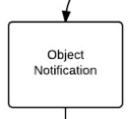
Figure 4-10: Object Notification
4.3.5.2.1 Assumptions
- The Object Notification Subsystem will have access to all of the notification devices.
- The signal will be unique.

4.3.5.2.2 Responsibilities
The Object Notification Subsystem will be responsible for interpreting the Warning Manager’s instructions and sending signals to the notification devices.

4.3.5.2.3 Dependencies
This subsystem will be dependent on the data received from the Warning Manager subsystem and the signals required by the notification devices.
4.3.5.2.4 Subsystem Inter-layer Interfaces
Method | Description | Information  Required | Information Returned
notificationListener | The Object Subsystem will listen for instructions from the Warning Manager. | Object Detection Message | None
Table 4-11: Object Notification Inter-layer Interfaces
4.3.5.2.5 Subsystem Public Interfaces
Method | Description | Information  Required | Information Returned
objectNotification | Notify the user that there is an object nearby with a unique signal. | Unique Signal | None
Table 4-12: Object Notification Public Interface
4.3.5.3 Battery Notification
The Battery Notification Subsystem will receive messages from the Warning Manager and interpret them into appropriate instructions.
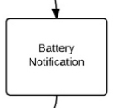
Figure 4-11: Battery Notification
4.3.5.3.1 Assumptions
- The Battery Notification Subsystem will have access to all of the notification devices.
- The signal will be unique.

4.3.5.3.2 Responsibilities
The Battery Notification Subsystem will be responsible for interpreting the Warning Manager’s instructions and sending signals to the notification devices.

4.3.5.3.3 Dependencies
This subsystem will be dependent on the data received from the Warning Manager subsystem and the signals required by the notification devices.
4.3.5.3.4 Subsystem Inter-layer Interfaces
Method | Description | Information  Required | Information Returned
notificationListener | The Notification Subsystem will listen for instructions from the Warning Manager | Low Battery Message | None
Table 4-13: Battery Notification Inter-layer Interfaces
4.3.5.3.5 Subsystem Public Interfaces
Method | Description | Information  Required | Information Returned
batteryNotification | Notify the user that the system’s battery is low with a unique signal. | Unique Signal | None
Table 4-14: Battery Notification Public Interface

5. Inter-Subsystem Data Flow

5.1 Inter-Subsystem Data Flow Section
This section details the data flow between each subsytem in the layered architecture of the Sight By Touch system.
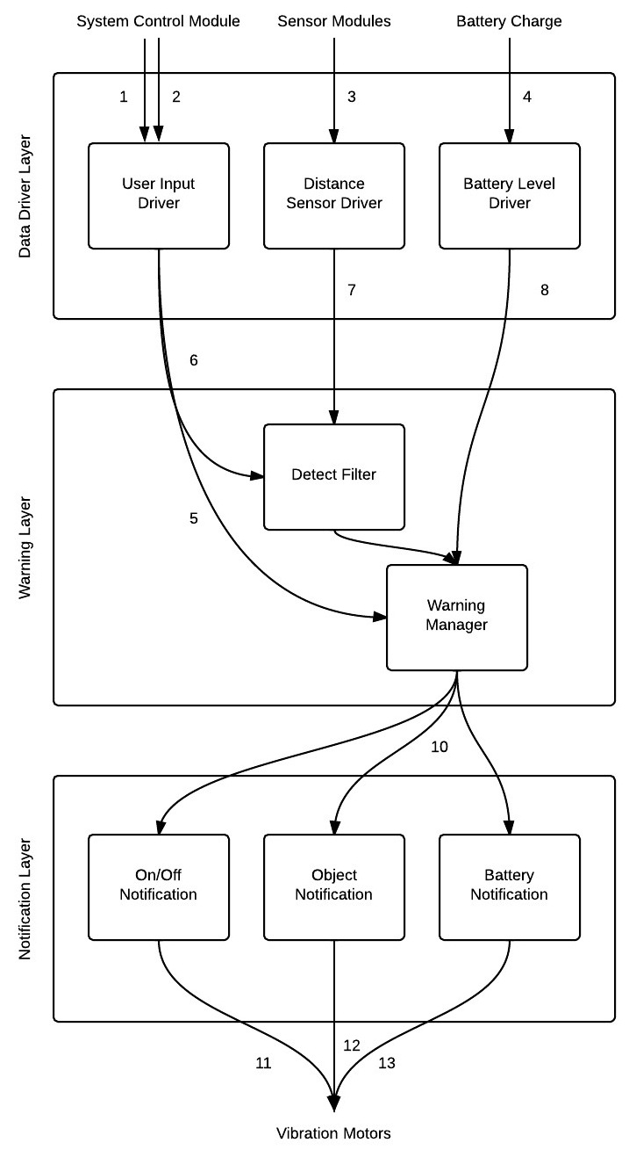
Figure 5-1: Architectural Data Flow Diagram
The following table will describe the data flows between subsystems in tabular form.
Table 5-1: Inter-Subsystem Data Element Descriptions
Data Element |  | Descriptions
1. On/Off input | The data from the system control module regarding the new state of system
2. Change Range Input | The data from the system control module regarding the new maximum detection range
3. Sensor Module Input | The sensor information containing the sensor ID and distance
4. Battery Input | The battery voltage
5. Detection Range | The new maximum range that will be used by the Detection Filter subsystem to determine whether the object detected is within the range specified by the user
6. New State of System | The new state of the system to determine whether the system is On/Off
7. Sensor Module Data | The sensor ID and distance
8. Battery Level | The numeric value of the battery voltage
9. Sensing Module Info | The sensor ID and distance
10. Broadcast Signal | A package containing the type of notification
11. On/Off Notification Signal | A unique signal that will notify the user that the system has been turned on/off
12. Object Notification Signal | A unique signal that will notify the user that the system has detected an object at a particular range
13. Low Battery Signal | A unique signal that will notify the user that the battery is low

The following table documents the actual data flow paths of the data elements between subsystems in the form of a Producer-Consumer matrix.
Table 5-2: Producer-Consumer Relationships
Producer Subsystem | Consumer Subsystem
Producer Subsystem | Detection Filter | Warning Manager | On/Off Notification | Object Notification | Low Battery Notification
User Input Driver | 5. | 6.
Distance Sensor Driver | 7.
Battery Level Driver |  | 8.
Detection Filter |  | 9.
Warning Manager |  |  | 10. | 10. | 10.

6. Requirements Mapping
Number | Requirement | Data Driver Layer | Warning Layer | Notification Layer
3.1 | On and Off | X | X
3.2 | Detect Obstructions | X | X
3.3 | Obstruction Notification |  |  | X
3.4 | Battery Powered | X | X
3.5 | Inconspicuous Appearance
3.6 | Low Battery Notification | X | X | X
3.7 | User Friendly | X |  | X
5.2 | Real-Time Response | X | X | X
5.3 | Detection Quality
5.4 | Vibration Intensity |  |  | X
5.5 | Battery Life | X | X | X
6.4 | Heat Dissipation |  | X
6.6 | Skin Irritation |  |  | X
8.1 | Weight
8.3 | Adjustable Range | X | X
Table 6-1: Requirements Mapping

7. Operating System Dependencies

7.1 Data Driver Layer
The Data Driver Layer will be dependent on the type of microcontroller and associated libraries used.

7.2 Warning Layer
The Warning Layer will be dependent on the type of microcontroller and associated libraries used.

7.3 Notification Layer
The Notification Layer will be dependent on the type of microcontroller and associated libraries used.

8. Testing Considerations
In this section, we will define testing considerations relevant to each layer of the architecture that are addressed in this section. This is not a full testing plan, but ideas and goals that address how we will verify and validate the architecture that we have specified.
This section is divided into two subsections. We define the considerations on how to approach the validation of our system overall and at each layer in the architecture.

8.1 Overall Considerations

Durability
- Wearing: The user shall be able to easily wear the System. Once worn, the System should stay on the user comfortably.
- Toughness: The System shall be able to withstand any normal day-to-day contact the user would normally experience during operation.

User
- Ease of Use: All layers should be designed and tested as to have minimal work for the user. The user should only be responsible for wearing the System, attaching connections to the System Control Unit, and communicating information from the user input in the Data Driver Layer. Any other functions required for the Sight By Touch System shall be handled by the System itself.
- Clarity: The Data Driver Layer and Notification subsystems shall clearly communicate with the user.

Layer-level Considerations

Data Driver Layer
- Minimal Integration: Any User input, Sensor Module input and Battery input should communicate individually to its driver subsystem inside the Data Driver Layer.
- Independence: Any subsystem within the Data Driver Layer shall be independent of each other, and should work and supply information in the case that any of the other subsystems fail. The Data Driver Layer’s performance shall be independent of the other layers.
- Data Acquisition: Data retrieved from the User, Sensor Modules and Battery shall be retrieved in a timely manner so that the Warning Manager can produce real time feedback.
- Communication: The Data Driver Layer must be able to gather and transmit appropriate information to the Warning Layer. This information must be preprocessed and prepared before being sent to the Warning Layer subsystems.

Warning Layer
- Centralized Control: All controls and decisions will be made in the Warning Layer. All communication with the Data Driver Layer is for the purposes of retrieving information.
- Independence: The Warning Layer shall be designed in a way that if a new Warning Layer was composed, no other layers shall need to be altered. Black Box Testing shall be utilized for all subsystems within the Warning Layer.

Notification Layer
- Correctness: The Notification Layer shall be designed with proper code to clearly differentiate between object, low battery, and on/off notifications.
- Independence: Any subsystem within the Notification Layer shall be independent of each other. The Notification Layer’s performance shall be independent of the other layers.

